Active Listening Skills for Professionals

Active listening skills are time-tested tools used by professionals in a wide range of occupations to enhance their work. Psychologists, talk show hosts, or police negotiators may use active listening skills more than any other set of skills. Though you may not be counseling someone in distress, getting a celebrity to reveal their emotions, or bargaining for hostages, the principles of active listening are the same. Active listening means listening attentively to the speaker's words, meaning, intent, and emotions in an unbiased positive way. Active listening also involves creatively utilizing a blend of discrete skills that can be brought to bear in any conversation to draw out additional meaning, intent, and emotions. In this course, you'll review more advanced listening skills to help you operate more effectively in your workplace. These skills include how to prepare your mind to actively listen, how to actively demonstrate "I'm listening," how to draw out thoughts and emotions from speakers, and how to steer conversations and ensure understanding.

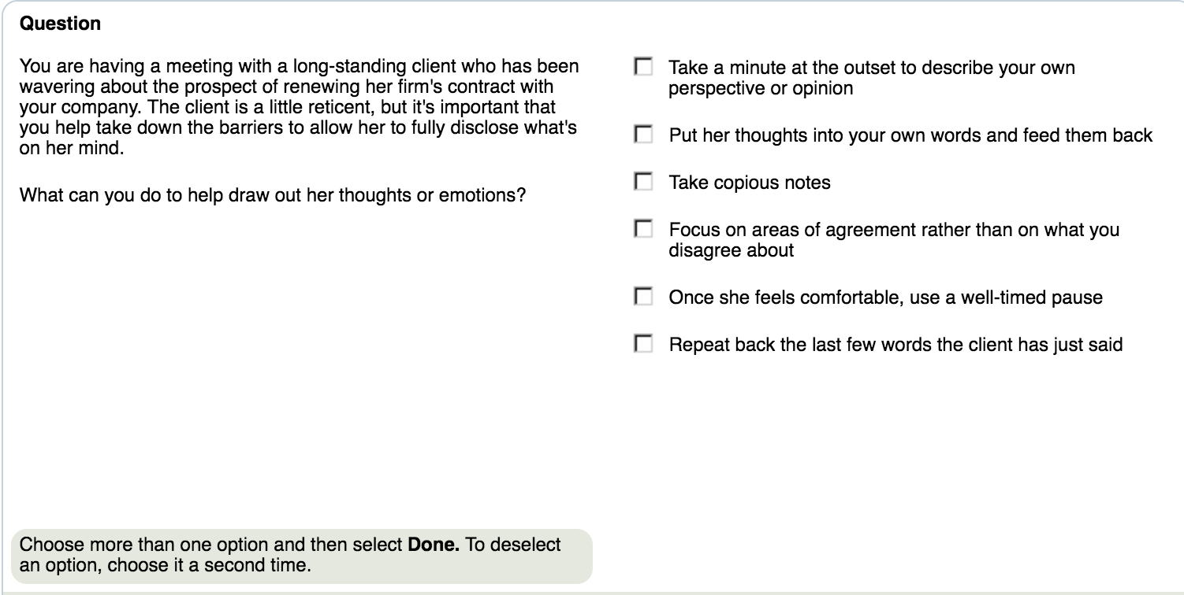

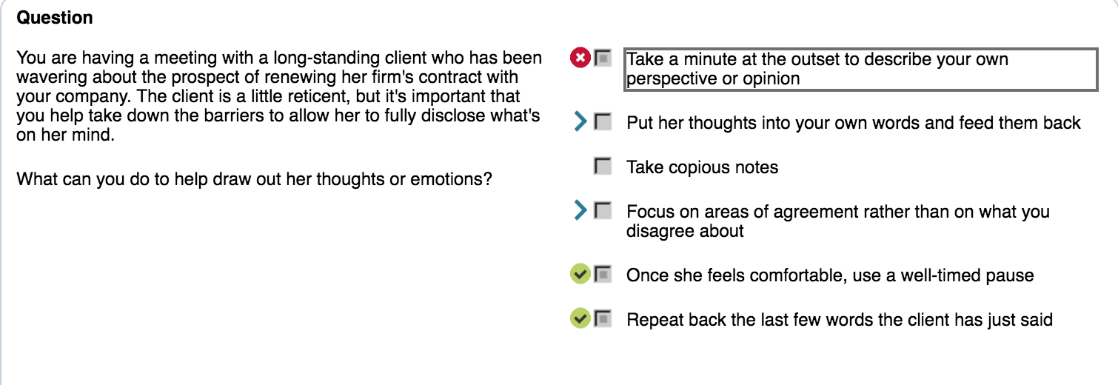

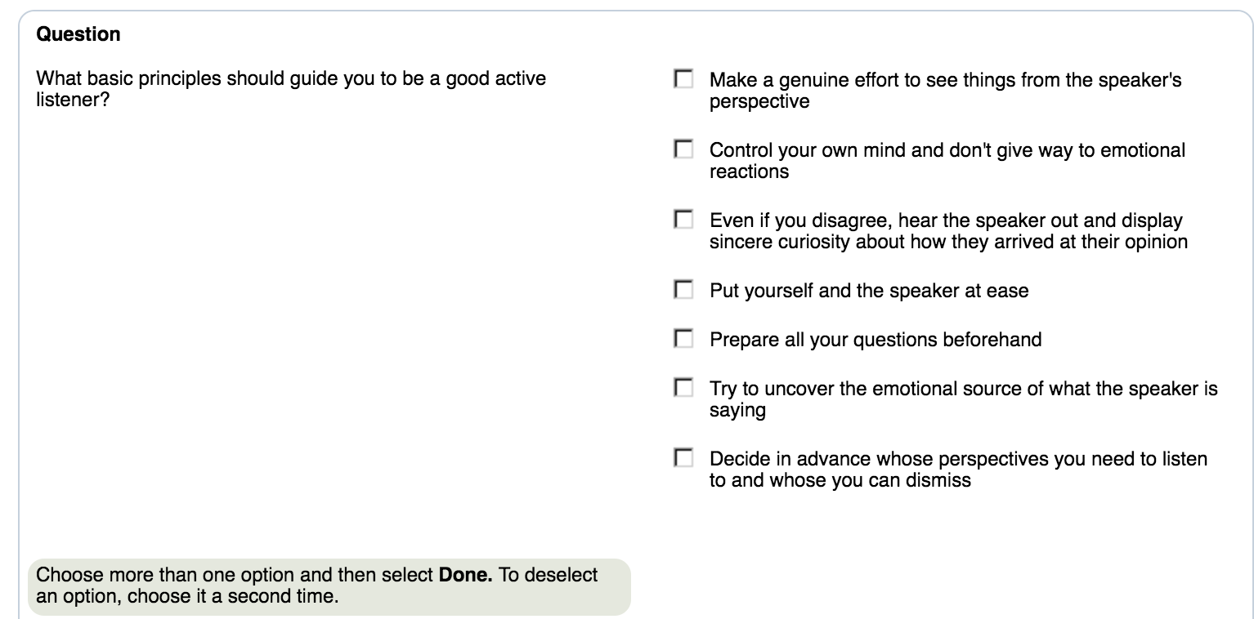

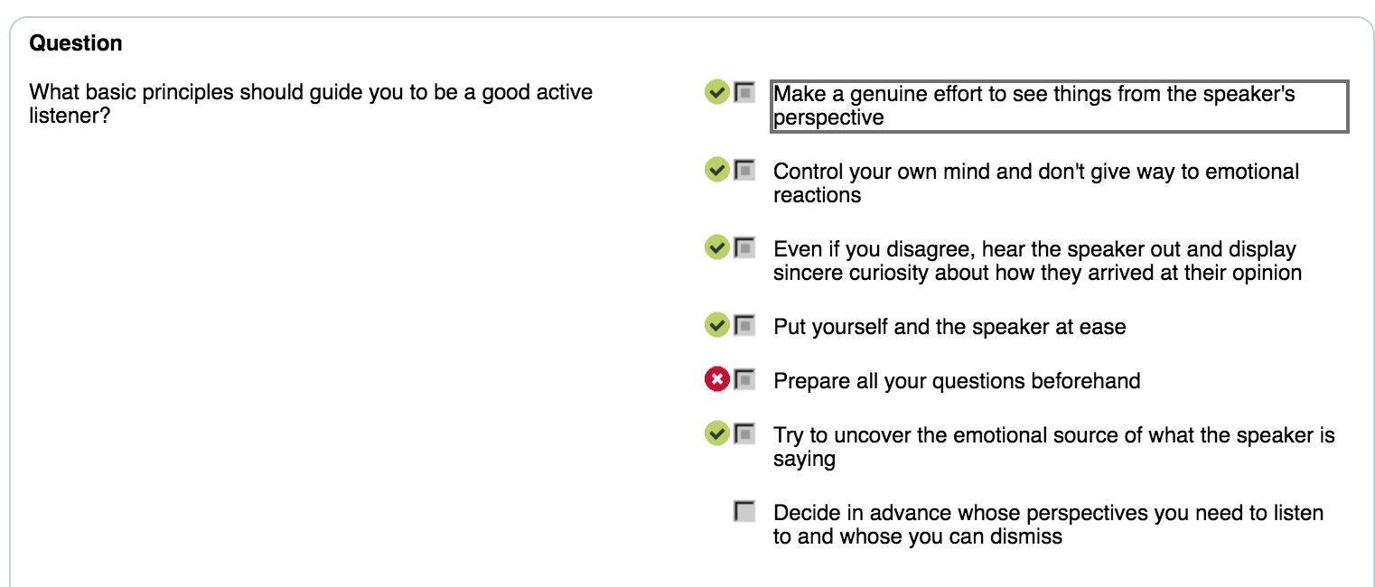

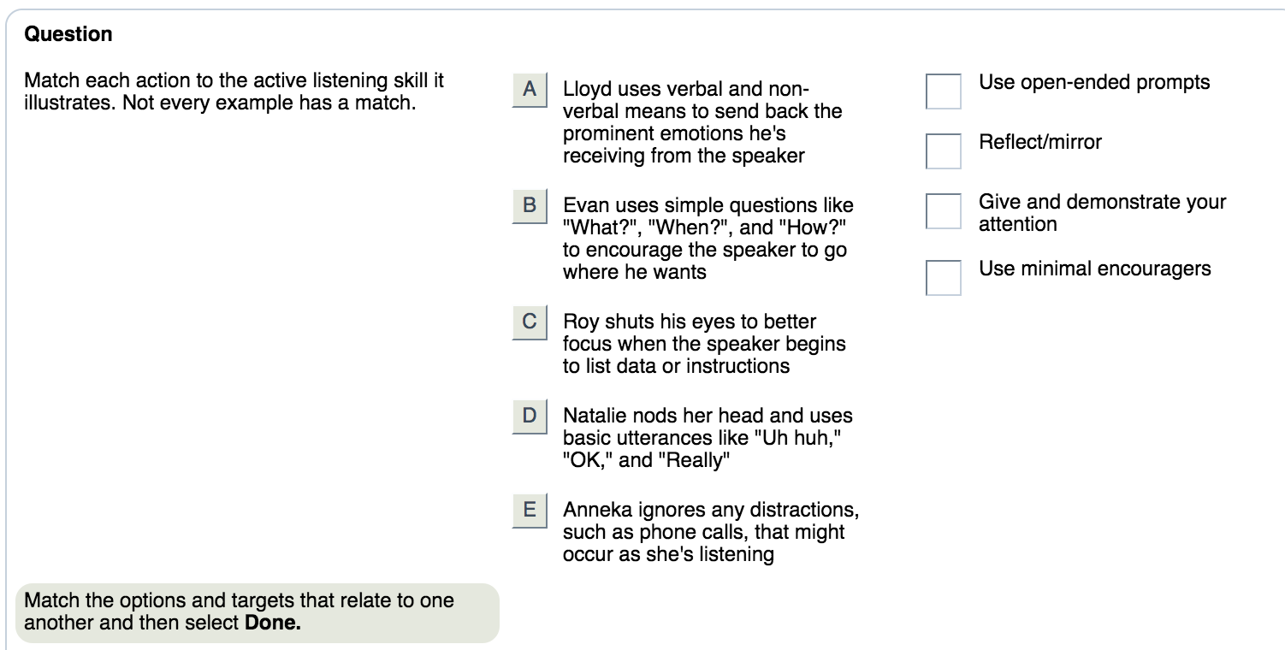

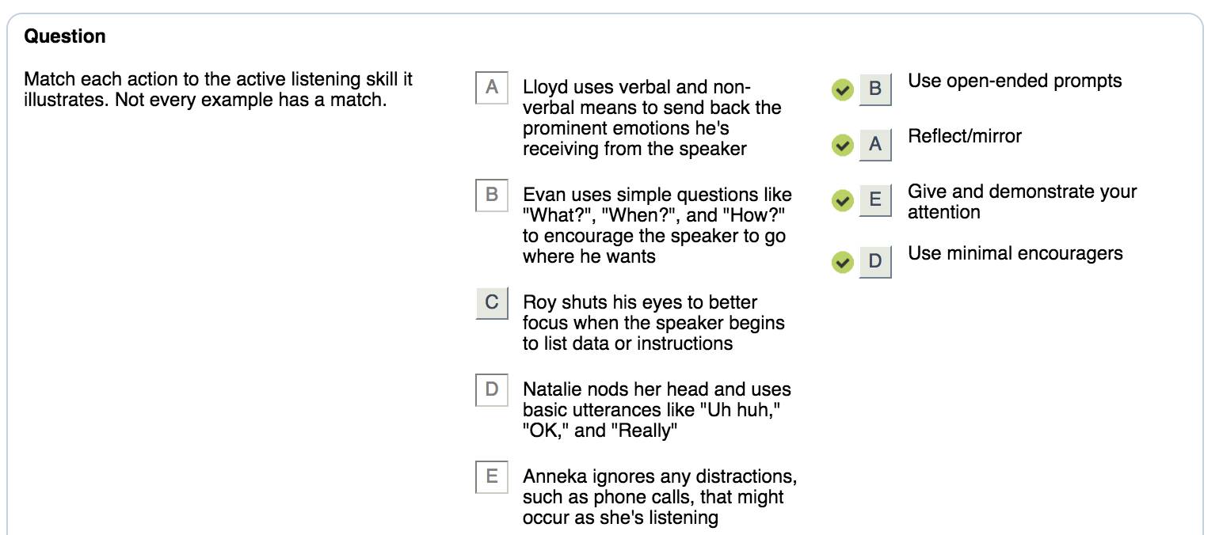

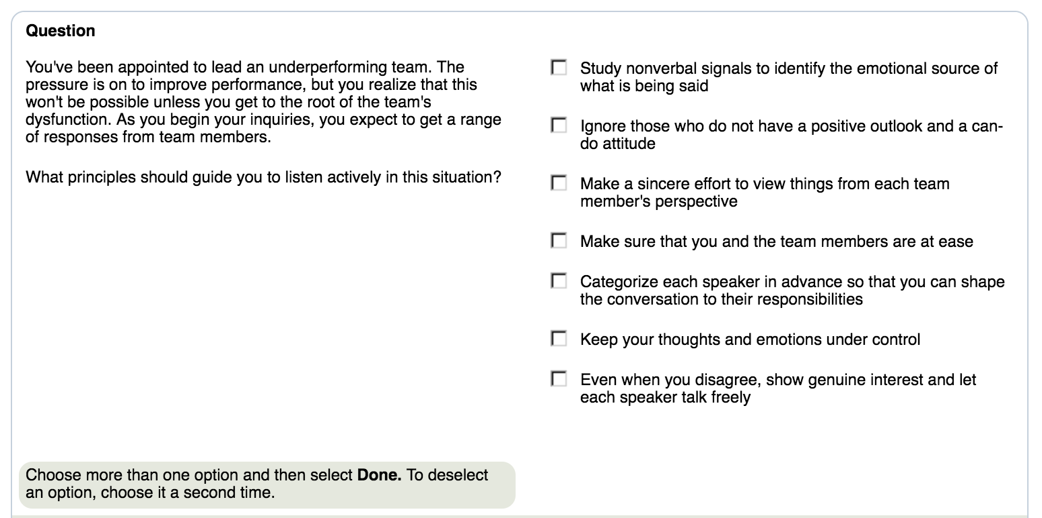

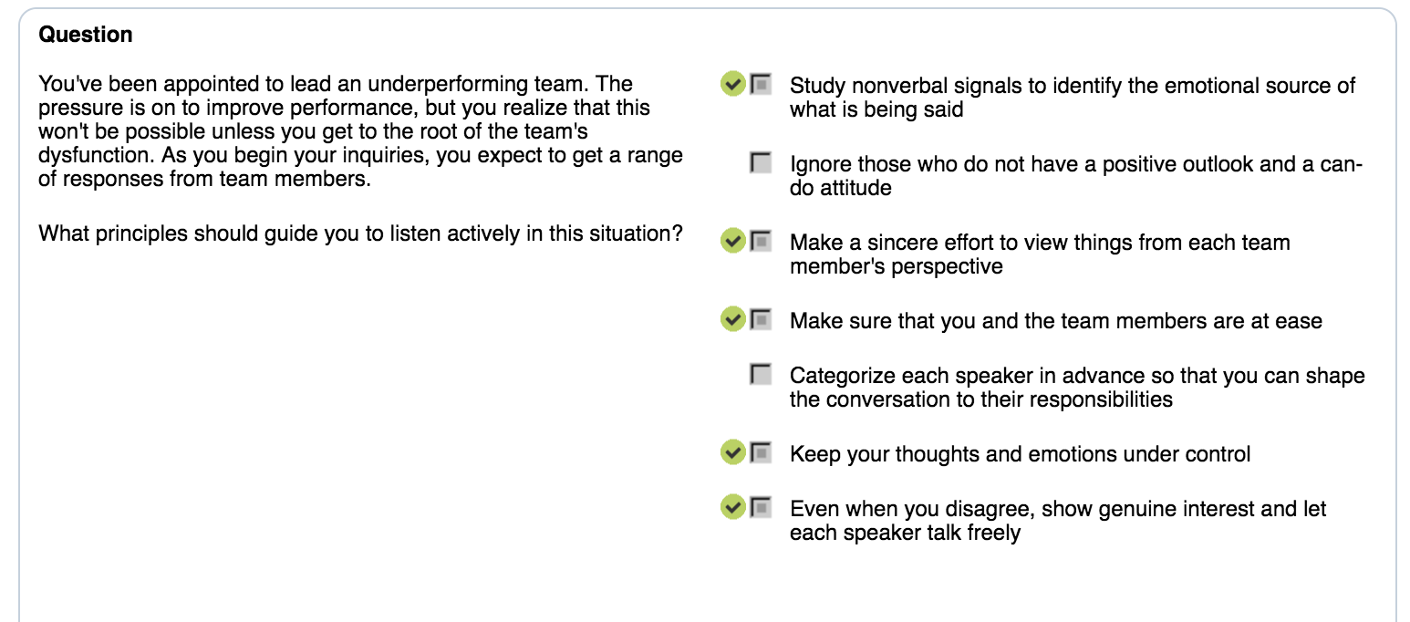

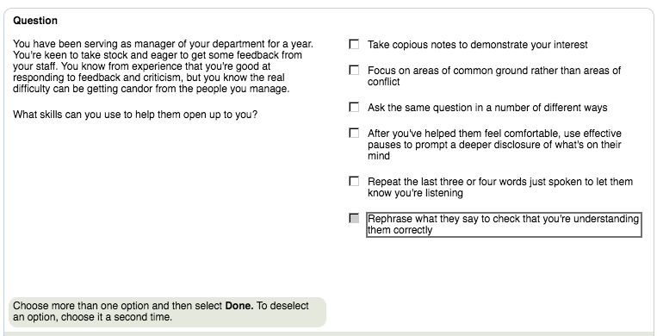

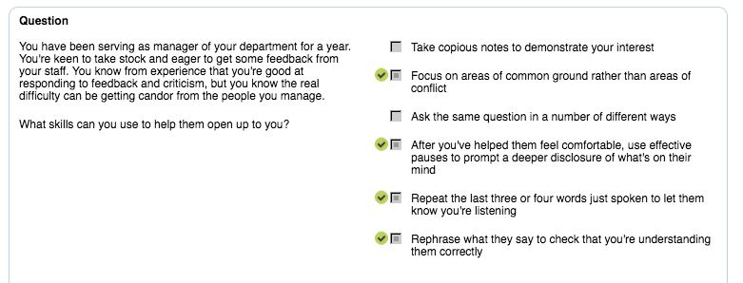

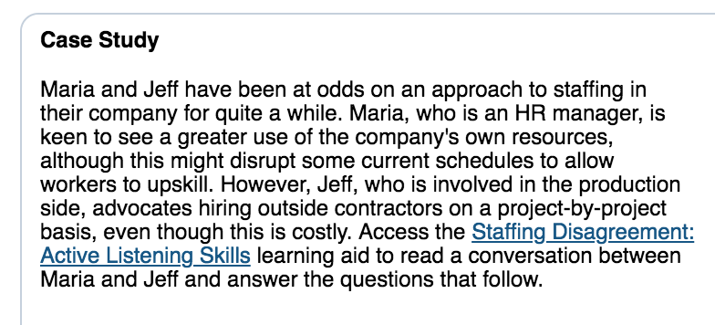

# **Staffing Disagreement: Active Listening Skills**

**Purpose:** Use this learning aid to help answer the questions in this case study.

**Jeff:** I hope you don't think you're going to persuade me to ditch the contractors. Retraining the current staff just isn't an option.

**Maria:** You say retraining the current staff won't work. What is the problem with that approach?

**Jeff:** I don't have the luxury of time for a worker to acquire the necessary skills to the required standard. I usually only receive a month's notice of a new project – not enough time to adequately upskill and demonstrate competence. I need to know that someone will perform to a high standard within the short turnaround time we work with.

**Maria:** If I'm hearing you right, you can't wait for someone to be trained to the required standard. You need workers of proven quality to operate within a very tight schedule.

**Jeff:** Exactly. I can't wait to see whether someone from another department can provide...

**Maria:** I'd like to stop you for a moment. You're not seeing this from my perspective.

**Jeff:** I'm very familiar with your perspective. We've been down this road before. There are other factors you're not considering. With the variety of projects we take on, we might only need some resources once. Where's the value in training someone on a skill we only need one time? Do you actually know what percentage of our work involves using the same resources?

**Maria:** It's useful to consider these production issues, but I think we need to discuss cutting the wage bill.

**Jeff:** OK. Once more with feeling I guess. [Jeff laughs]

**Course:** Active Listening Skills for Professionals  
**Topic:** Skills To "Steer" and Ensure Understanding

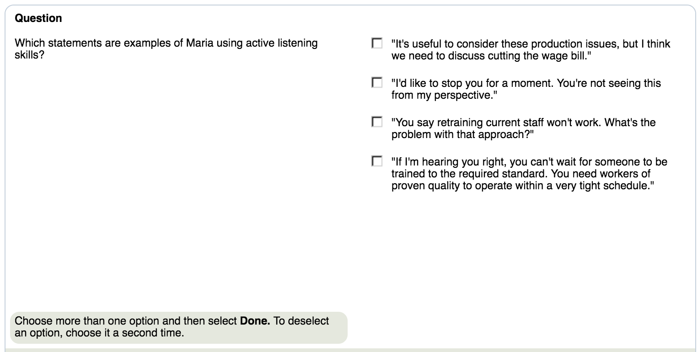

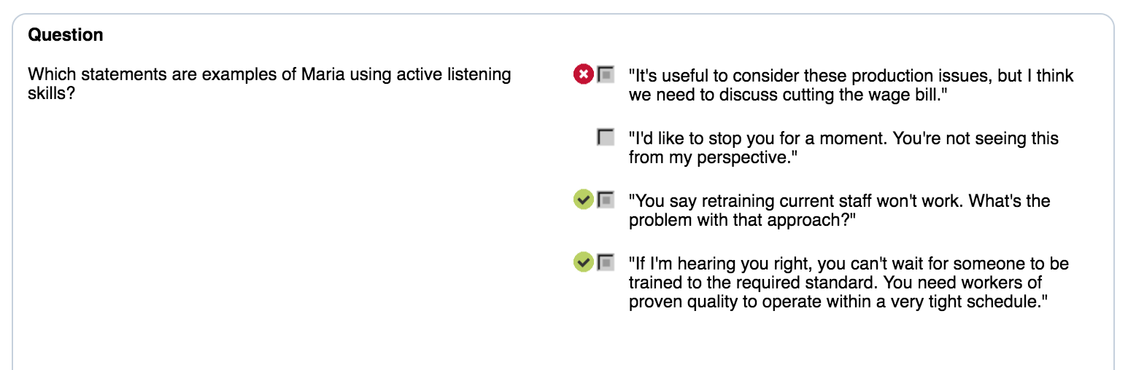

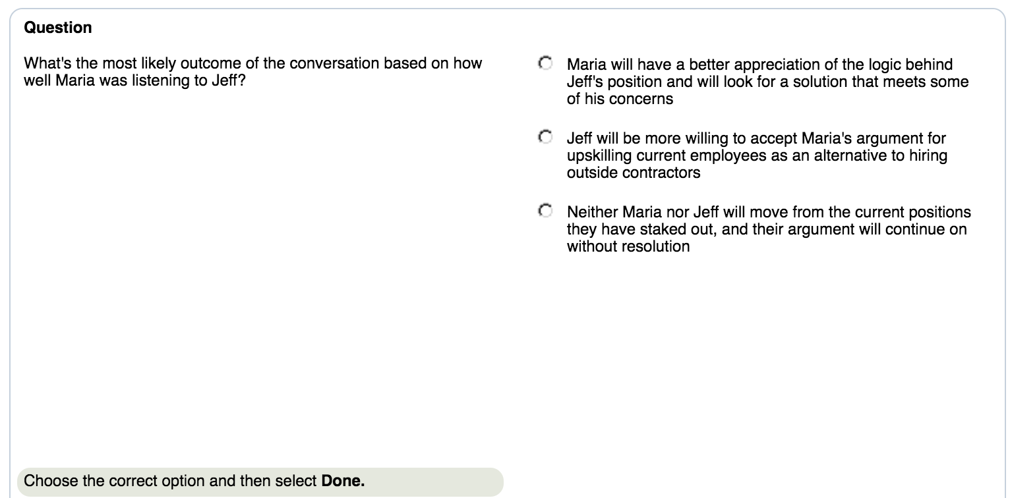

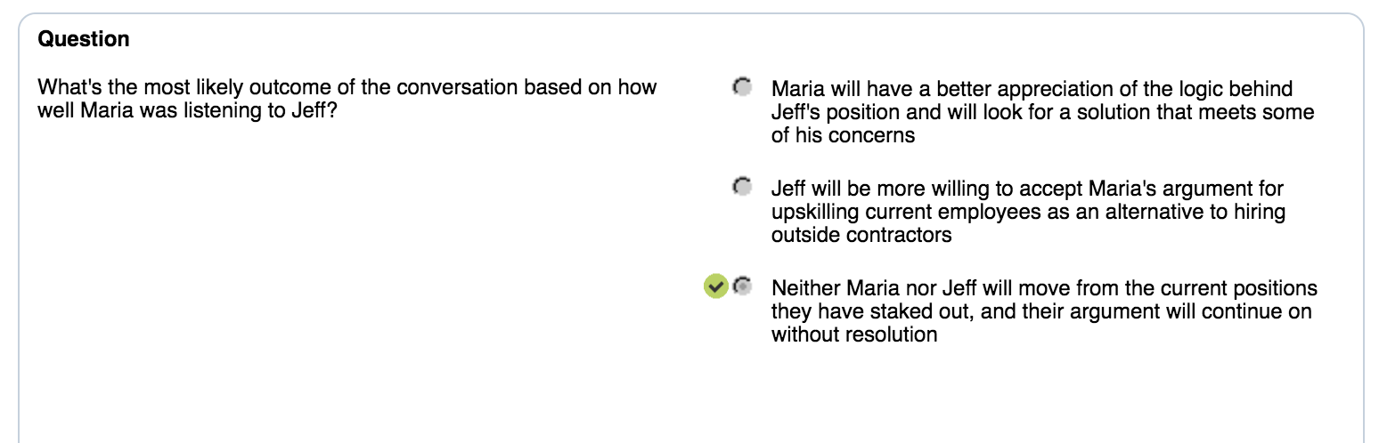

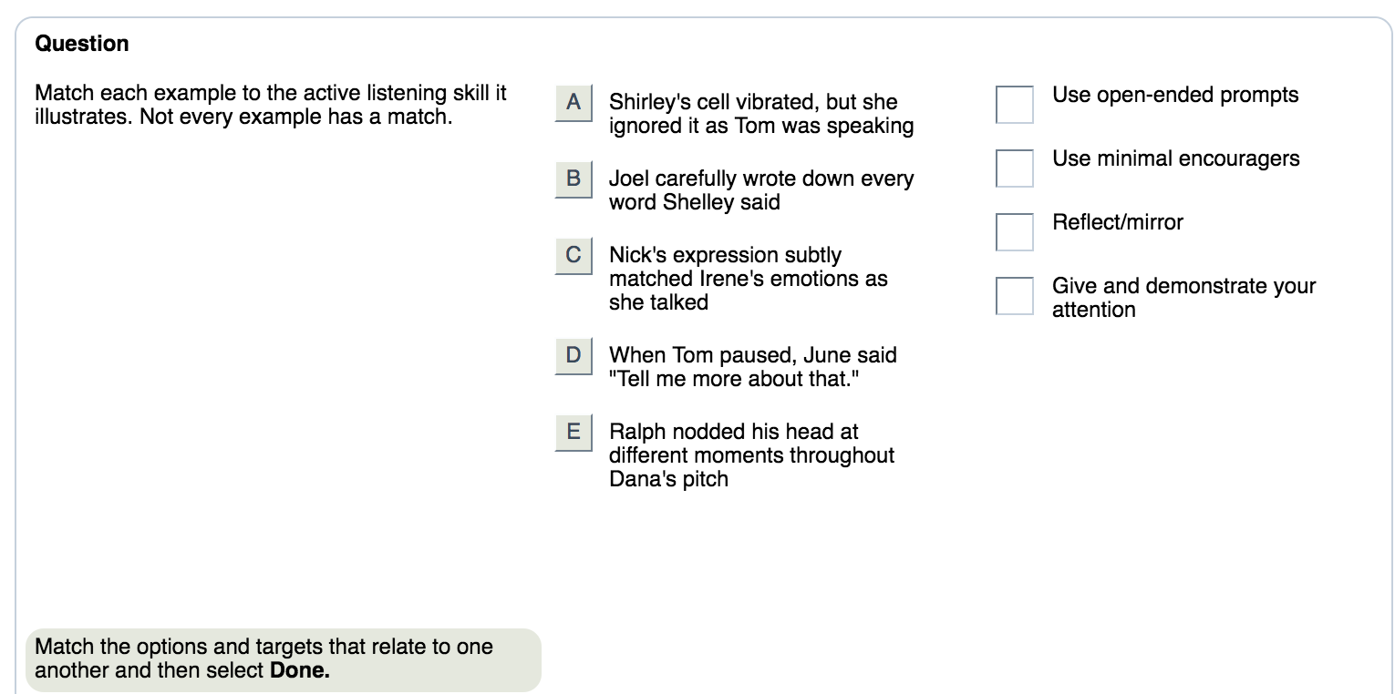

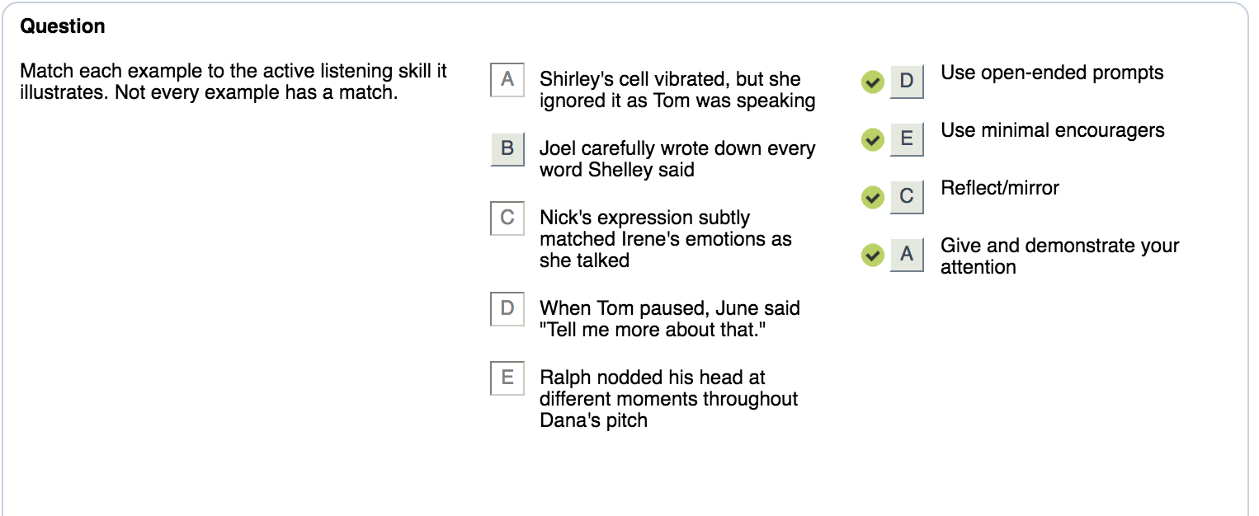

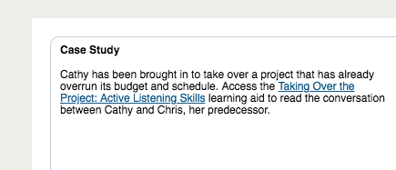

# **Taking Over the Project: Active Listening Skills**

**Purpose:** Use this learning aid to help answer the questions in this case study.

**Chris:** The failures were baked into this project. It was underfunded to begin with and then the schedule was compressed to meet marketing's demands. But nobody is going to point the finger at finance or marketing. It's much easier to blame me, even if that's unfair and damaging.

**Cathy:** I'm hearing some frustration and a lot of concern about how this might impact on your reputation.

**Chris:** You're right that I'm annoyed and concerned. None of this is going to do my reputation any good! Of course now they realize that the deadline was unrealistic and that more resources are needed. But that was always the case and I said so.

**Cathy:** You should have made this argument more strongly at the outset.

**Chris:** Easy for you to say. And of course now you get to sweep in and fix things, like a white knight riding in to the rescue. I already know what needs to be done to put things right, but they're more interested in making it look like this is all my fault.

**Cathy:** You say you know what needs to be done to put things right. What specific steps do you have in mind?

**Chris:** First I – or rather you – need marketing to reset the deadline. Then you need to talk to finance about a revised budget. You're going to need two additional people to get this done in a reasonable timeframe. And I think you need to get the whole team together to discuss the situation. I'm worried about morale.

**Cathy:** I think I've got a good handle on the whole situation. Thanks.

**Chris:** Oh, OK. Sure.

**Course:** Active Listening Skills for Professionals  
**Topic:** Skills to "Steer" and Ensure Understanding

